Vanilla NeRF

Vanilla NeRF synthesizes novel views of complex scenes by optimizing a continuous underlying function representing a scene that takes a 5d input (x,y,z location and 2d viewing direction) and provides a 2d output of color and density. This function is optimized using an MLP which is then queried along a ray and then condensed into a color using volume rendering techniques. [Read the Original Paper Here.](https://www.matthewtancik.com/nerf)

## About Clarity

The final result was extremely unclear for the one final result we did get. It almost feels like a point cloud with just the colors of the original dataset.

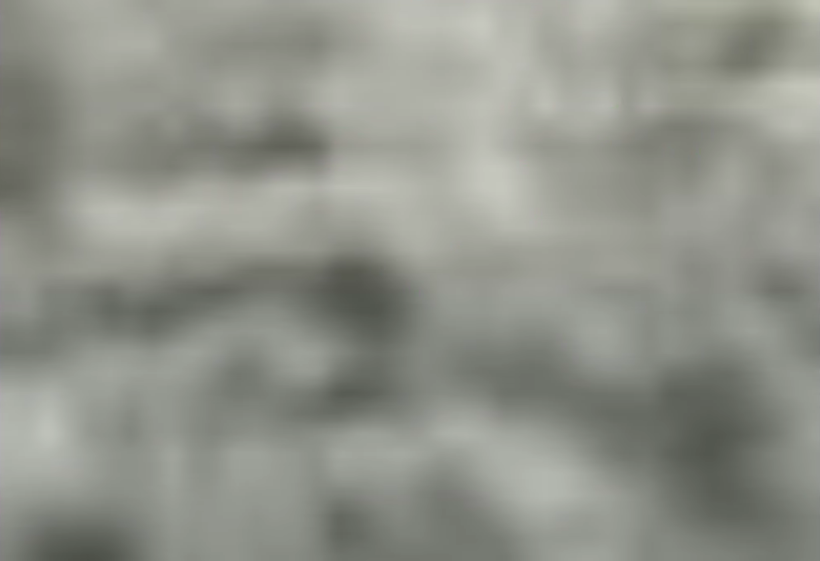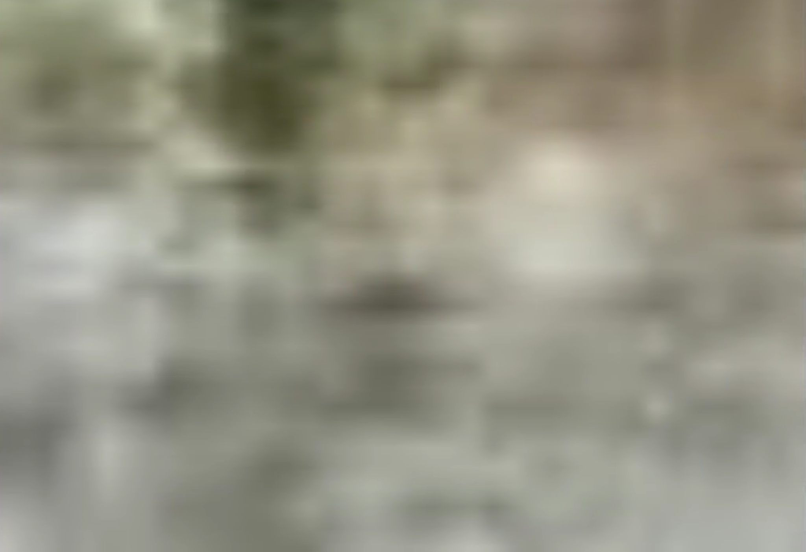

## About Errors

The entire thing is distorted and wrong. This is likely due in part to our dataset not being optimized for NeRF, but is also likely an error with the Vanilla NeRF pipeline in Nerfacto. We expected some visual errors in this type of dataset for a NeRF but not to this level.

## About Accuracy

It is very inaccurate to the ground truth, the entire NeRF looks like the above images. While the ground truth looks like the images below.

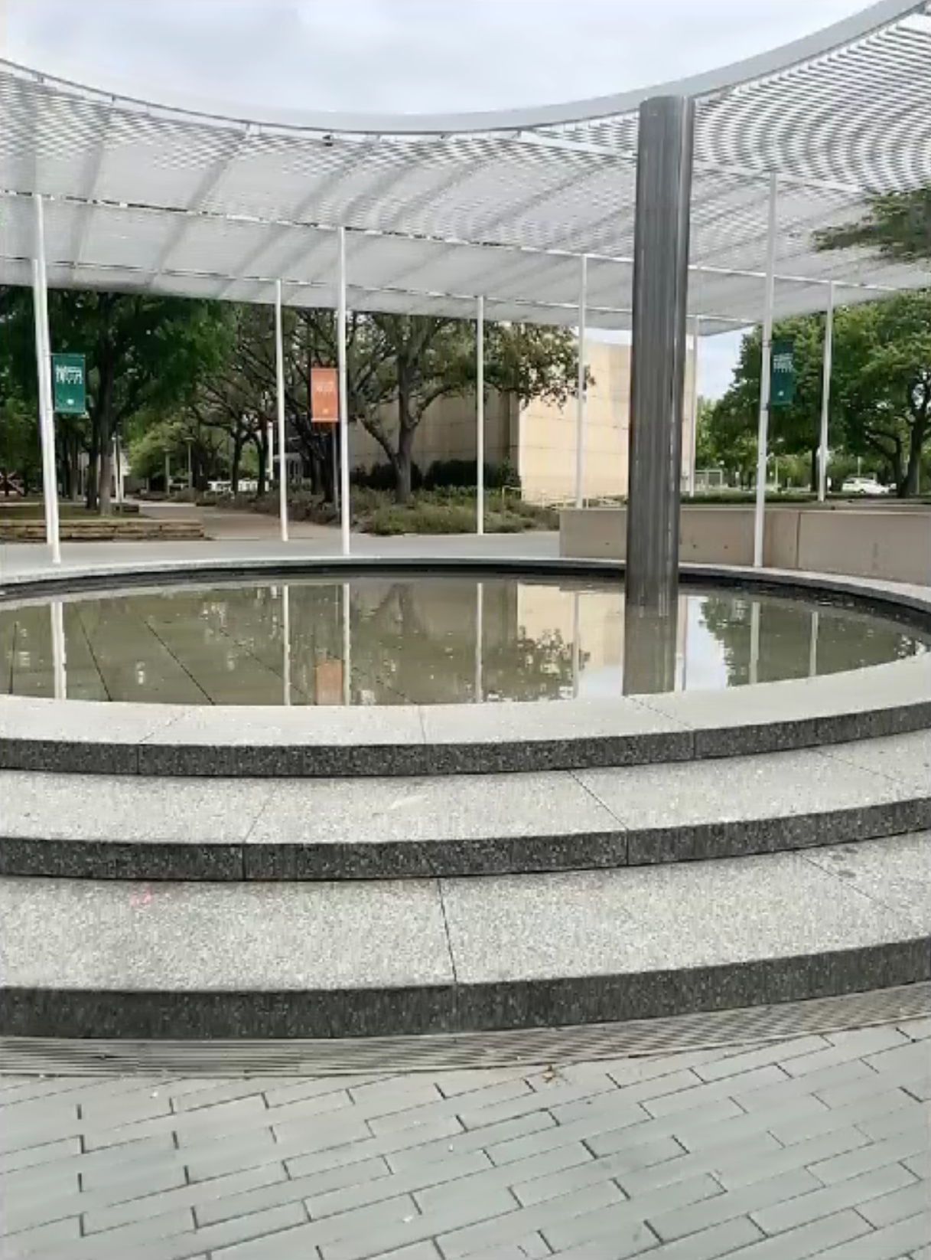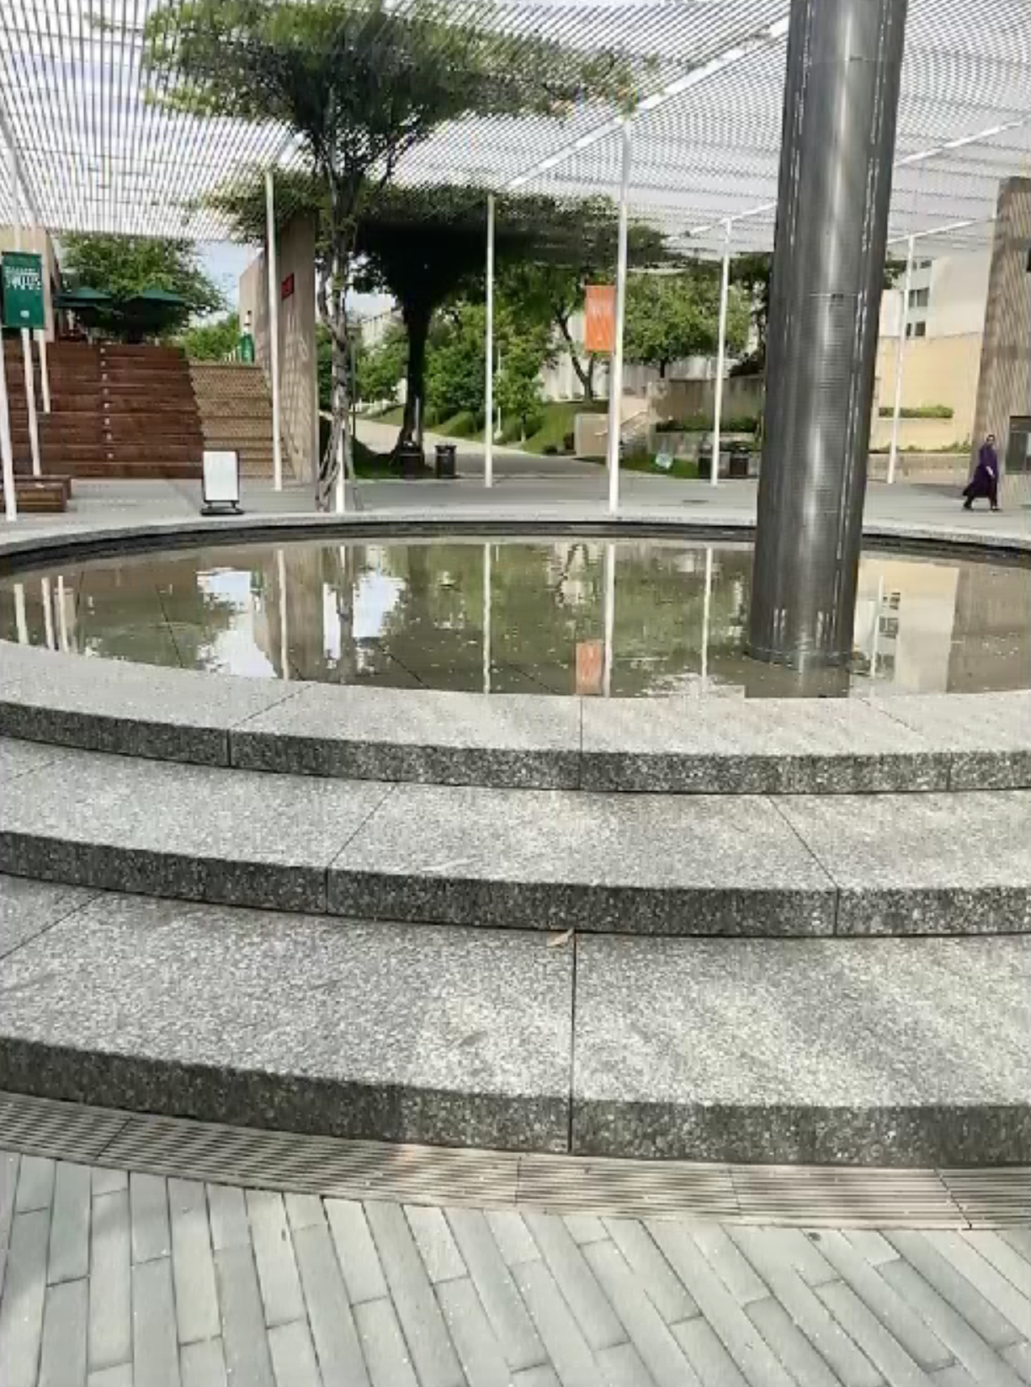

## Overall Immersion Rating

This method, at least default through the Nerfstudio, is not fit at all for immersive environments. Without seeing the colors of the original dataset it is unclear that it was trained at all. Maybe using other pipelines that utilize this method better it would be more immersive, but not without significant time and computational resources.